| **NAME** | V. VISHNU |
| --- | --- |
| **REG. NO.** | 420121106060 |
| **DEPARTMENT** | ECE |
| **YEAR** | III |
| **COLLEGE NAME** | AKTMCET |
| **GROUP** | IBM GROUP-2 |

**AQM- AIR QUALITY MONITORING**

**PHASE-2**

**Innovation**

* In this phase you need to put your design into innovation to solve the problem.
* Explain in detail the complete steps that will be taken by you to put your design that you thought of in previous phase into transformation.
* Create a document around it and share the same for assessment.

**Module 3:** Getting started with ESP32 and Wokwi Platform

**ESP32 WiFi Networking**

Wokwi simulates a WiFi network with full internet access. You can use the ESP32 together with the virtual WiFi to prototype IoT projects.

**Common use cases include:**

* Connect to MQTT servers to send sensor data
* Query web services over HTTP, HTTPS, and web sockets
* Run an HTTP server inside the ESP32 and connect to it from your browser (requires the Wokwi IoT Gateway)

**Connecting to the WiFi**

The simulator provides a virtual WiFi access point called Wokwi-GUEST. It is an open access point – no password is required.

**Connecting from Arduino**

To connect from Arduino (on an ESP32) device, use the following code:

#include <WiFi.h>

void setup() {

Serial.begin(9600);

Serial.print("Connecting to WiFi");

WiFi.begin("Wokwi-GUEST", "", 6);

while (WiFi.status() != WL_CONNECTED) {

delay(100);

Serial.print(".");

}

Serial.println(" Connected!");

}

void loop() {

delay(100); // TODO: Build something amazing!

}

**Viewing WiFi traffic with Wireshark**

Wokwi simulates a complete network stack: starting at the lowest 802.11 MAC Layer, through the IP and TCP/UDP layers, all the way up to protocols such as DNS, HTTP, MQTT, CoAP, etc. You can view the raw WiFi traffic using a network protocol analyzer such as Wireshark.

**Project Examples**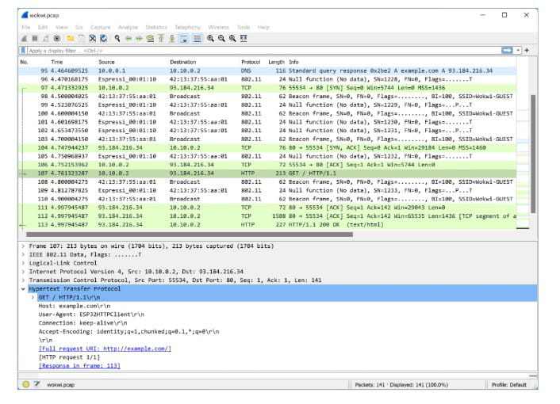

* NTP Client – Gets the current date and time from an NTP server and displays them on an LCD screen.
* MicroPython MQTT Weather Logger – Reads the current temperature + humidity every second and report changes to an MQTT server.
* ESP32 HTTP Server – Serves a web page that controls 2 LEDs. Requires the Wokwi IoT Gateway.

**Module 4:** IoT Communication Technologies

**Introduction:**

IoT Communication: IoT is the connection of devices over the internet, where these smart devices communicate with each other , exchange data , perform some tasks without any human involvement. These devices are embedded with electronics, software, network and sensors which help in communication.

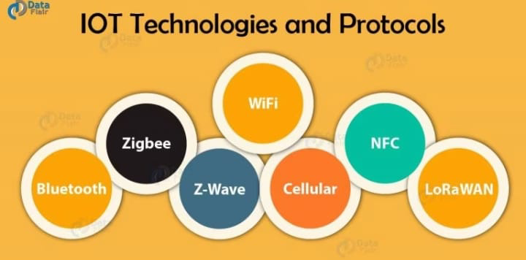

**Bluetooth**

* An important short-range IoT communications Protocols / Technology. Bluetooth, which has become very important in computing and many consumer product markets.
* The new Bluetooth Low-Energy (BLE) – or Bluetooth Smart, as it is now branded – is a significant protocol for IoT applications. Importantly, while it offers a similar range to Bluetooth it has been designed to offer significantly reduced power consumption.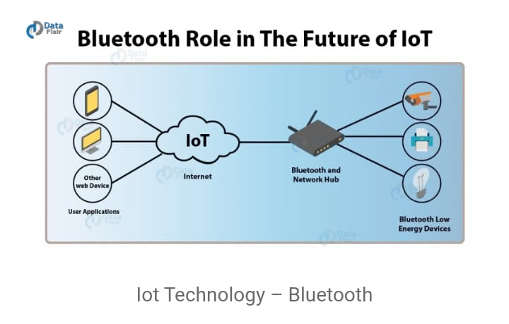

**NFC**

* NFC (Near Field Communication) is an IoT technology. It enables simple and safe communications between electronic devices, and specifically for smartphones.
* It helps the user to access digital content and connect electronic devices. Essentially it extends the capability of contactless card technology and enables devices to share information at a distance that is less than 4cm.

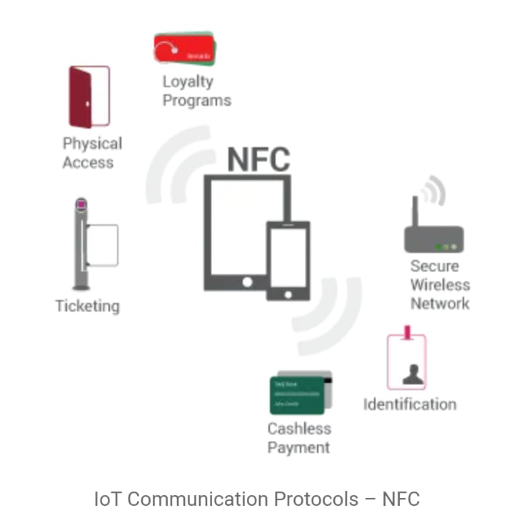

**Module 5:** IoT protocols

**Top 12 most commonly used IoT protocols and standards**

Not every IoT communication protocol is right for every deployment or device. Consider the power and security requirements before choosing one protocol over another.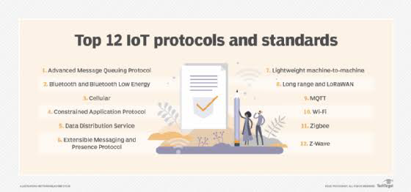

**The layers are the following:**

1. Physical
2. Data link
3. Network
4. Transport
5. Session
6. Presentation
7. Application

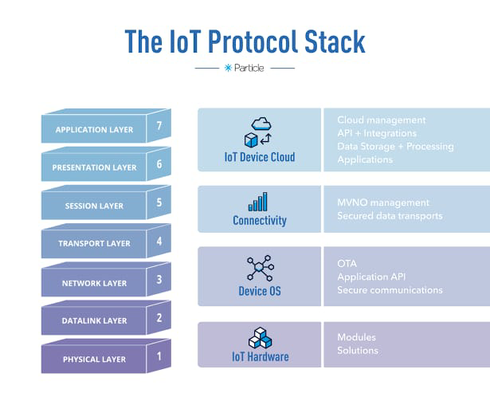

**IoT applications of current technologies**

**AI and IoT**

IoT systems gather such massive amounts of data that it’s often necessary to use AI and machine learning to sort and analyze that data so that you can detect patterns and take action on insights. For example, AI can analyze data gathered from manufacturing equipment and predict the need for maintenance, reducing costs and downtime from unexpected breakdowns.

**Blockchain and IoT**

Currently, there is no way to confirm that data from IoT has not been manipulated before it gets sold or shared.

**Kubernetes and IoT**

With a zero-downtime deployment model, Kubernetes helps IoT projects stay updated in real-time without impacting users. Kubernetes scales easily and efficiently using cloud resources, providing a common platform for deployment to the edge.

**Open source and IoT**

Open source technologies are accelerating IoT, allowing developers to use the tools of their choice on IoT technology applications.

**Quantum computing and IoT**

The significant amount of data generated by IoT naturally lends itself to quantum computing’s ability to speed through heavy computation.

**Serverless and IoT**

Serverless computing enables developers to build applications faster by eliminating the need for them to manage infrastructure. With serverless applications, the cloud service provider automatically provisions, scales, and manages the infrastructure required to run the code.